Assignment 03

Name – Lande Sudam Div - B Roll No- 94

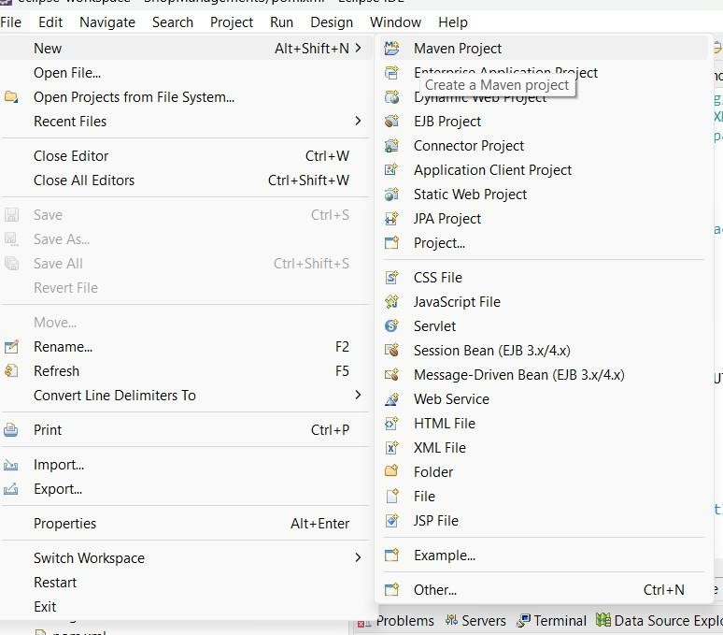

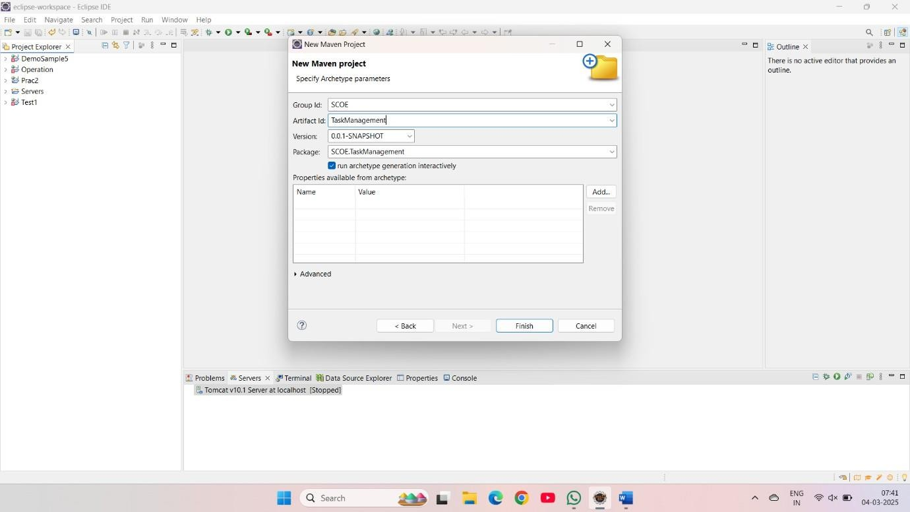

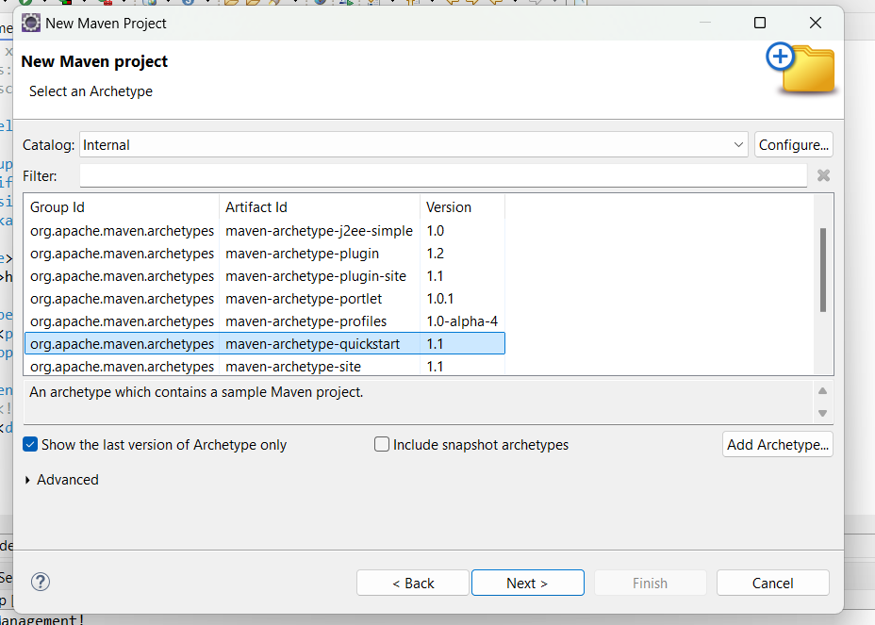

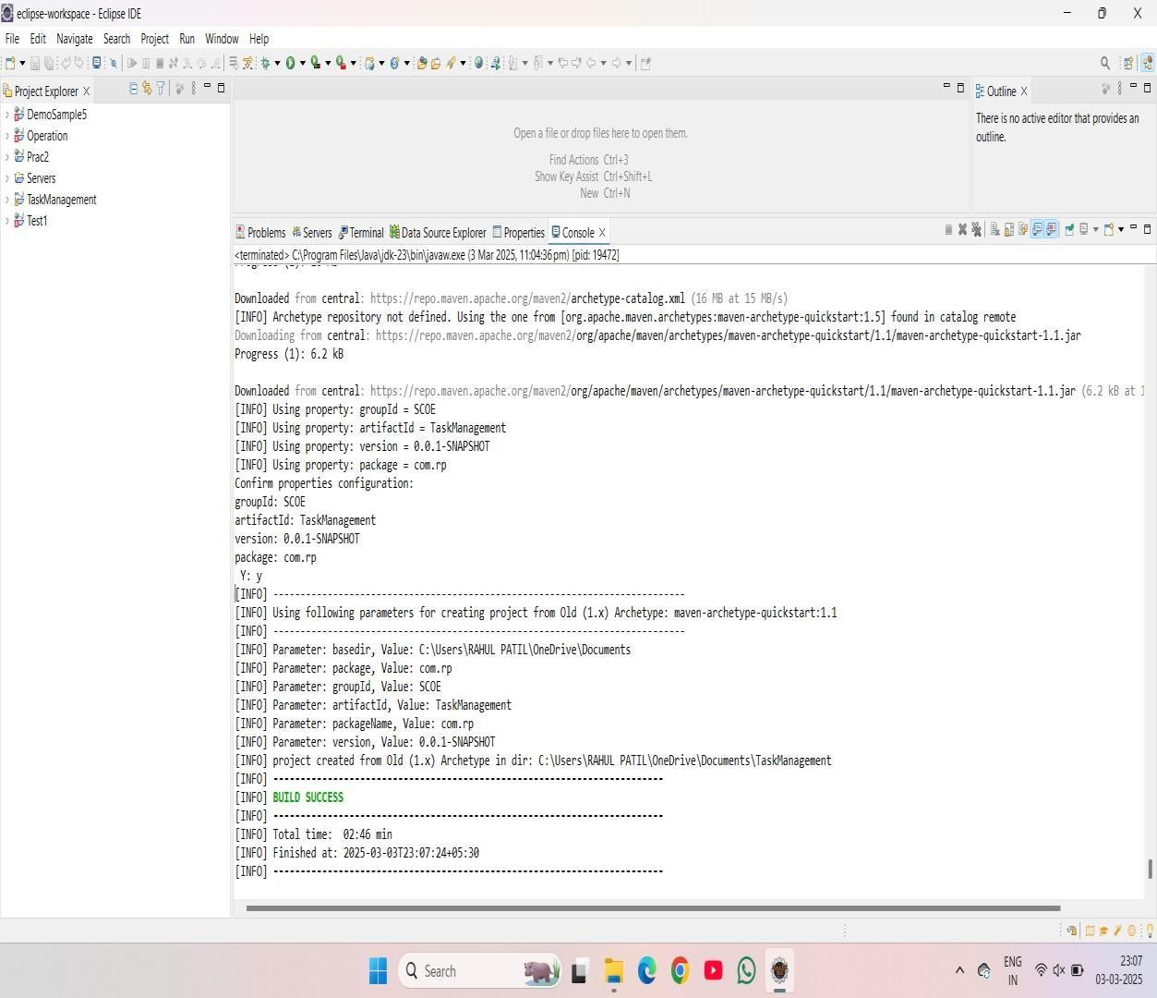

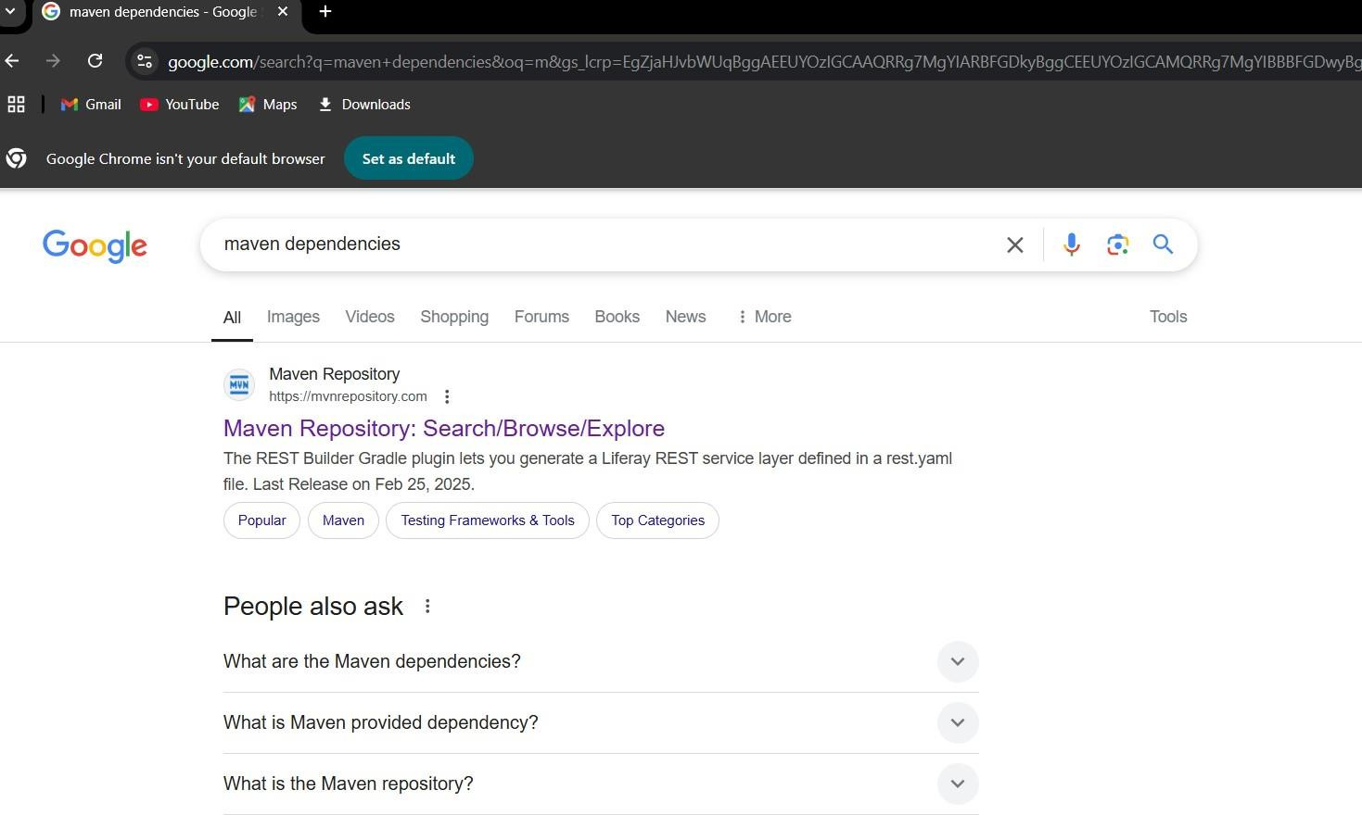

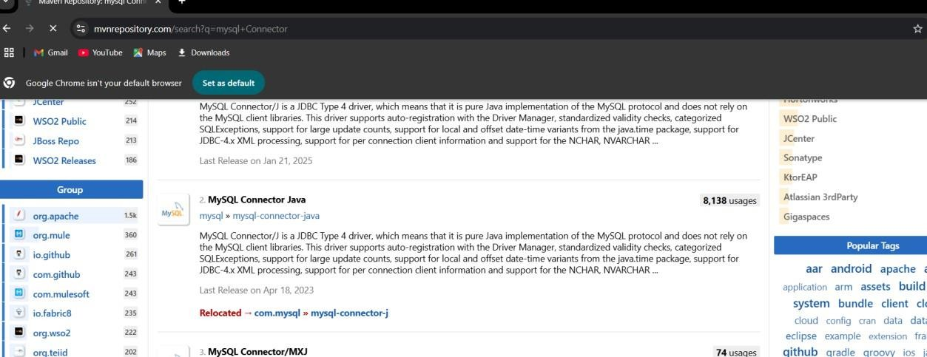

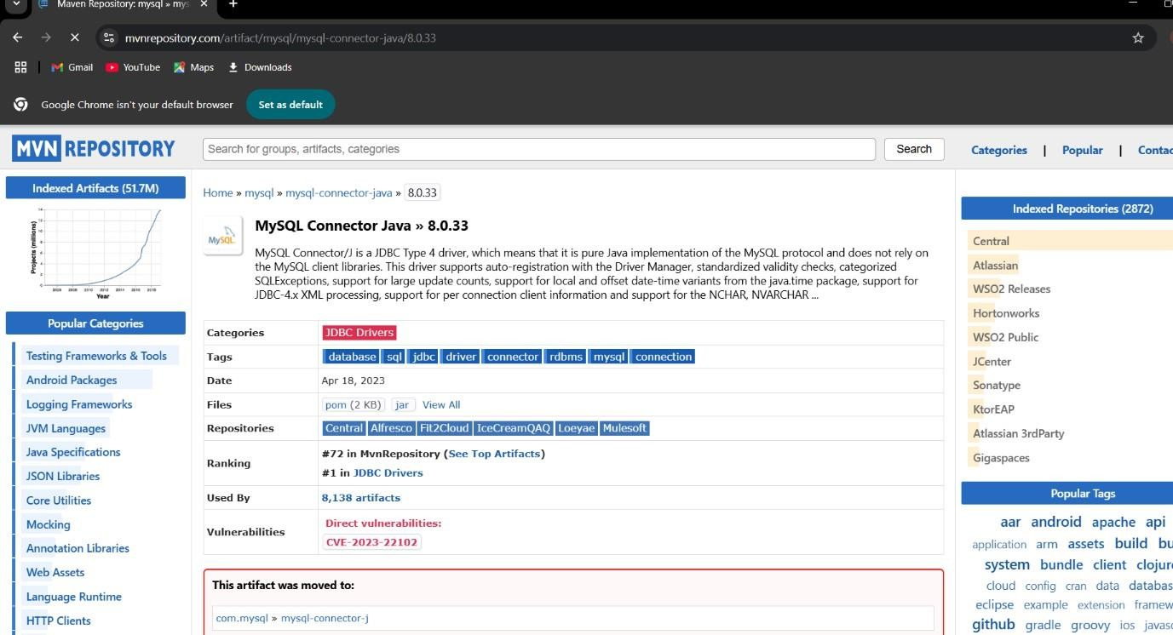

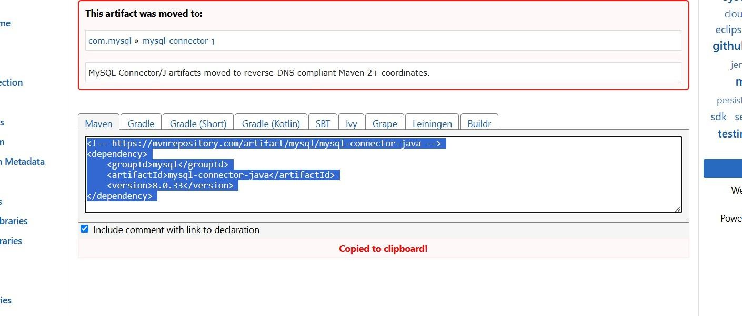

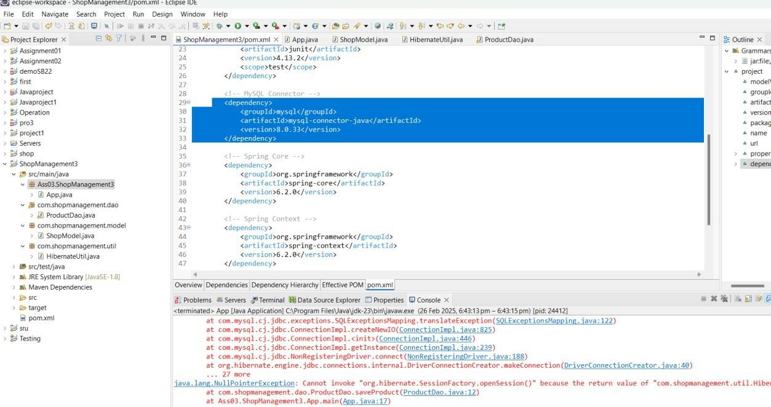

<dependency>

<groupId>mysql</groupId>

<artifactId>mysql-connector-java</artifactId>

<version>8.0.33</version>

</dependency>

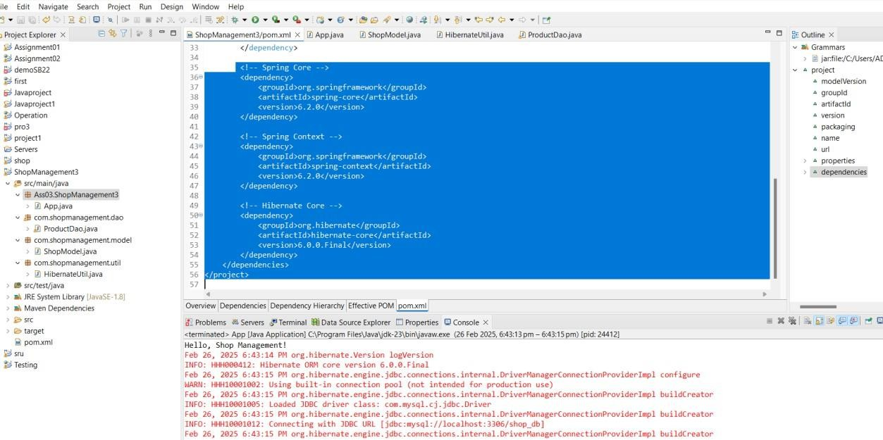

<dependency>

<groupId>org.springframework</groupId>

<artifactId>spring-core</artifactId>

<version>6.2.0</version>

</dependency>

<!-- Spring Context -->

<dependency>

<groupId>org.springframework</groupId>

<artifactId>spring-context</artifactId>

<version>6.2.0</version>

</dependency>

<!-- Hibernate Core -->

<dependency>

<groupId>org.hibernate</groupId>

<artifactId>hibernate-core</artifactId>

<version>6.0.0.Final</version>

</dependency>

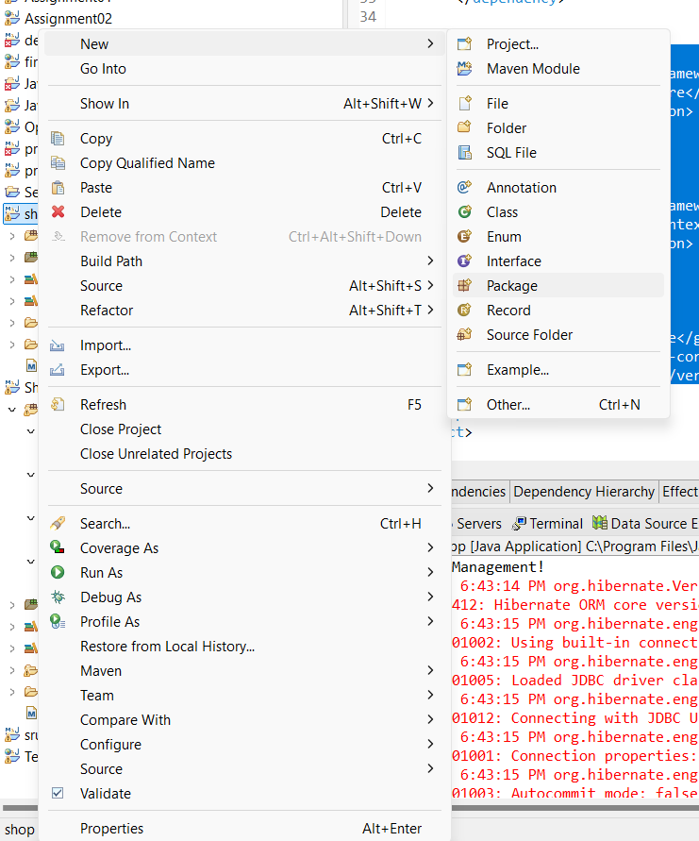

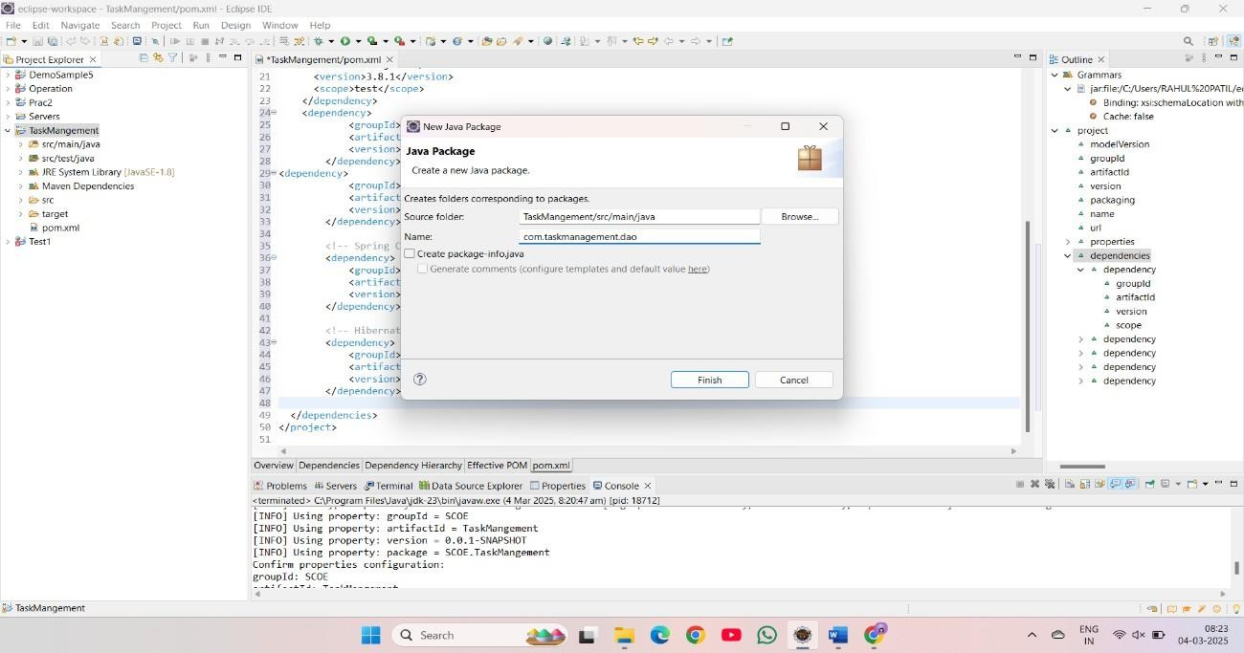

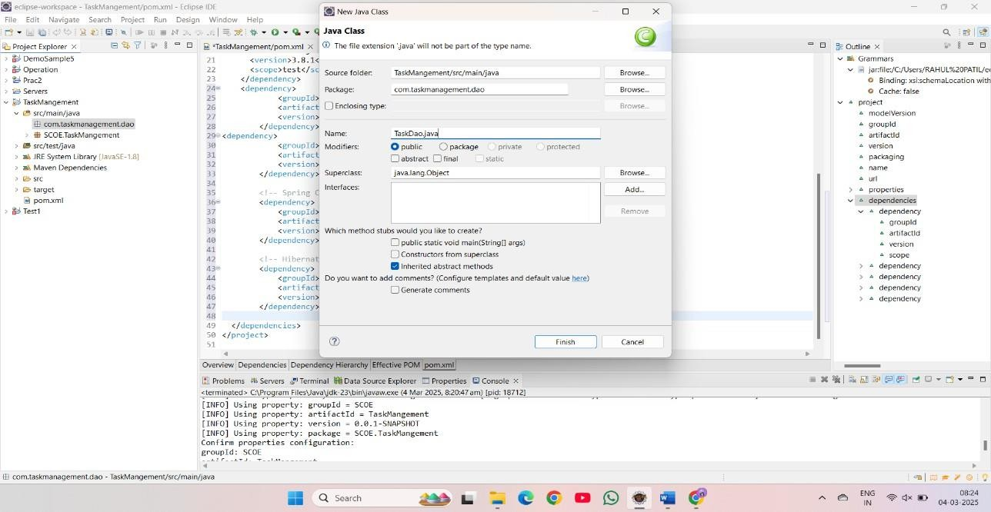

package com.taskmanagement.dao;

import org.hibernate.Session; import org.hibernate.Transaction;

import com.taskmanagement.model.Task;

import com.taskmanagement.util.HibernateUtil;

public class TaskDao {

public void saveTask(Task task) { Transaction transaction = null;

try (Session session = HibernateUtil.getSessionFactory().openSession()) { transaction = session.beginTransaction();

session.save(task); transaction.commit();

} catch (Exception e) {

if (transaction != null) { transaction.rollback();

}

e.printStackTrace();

}

}

}

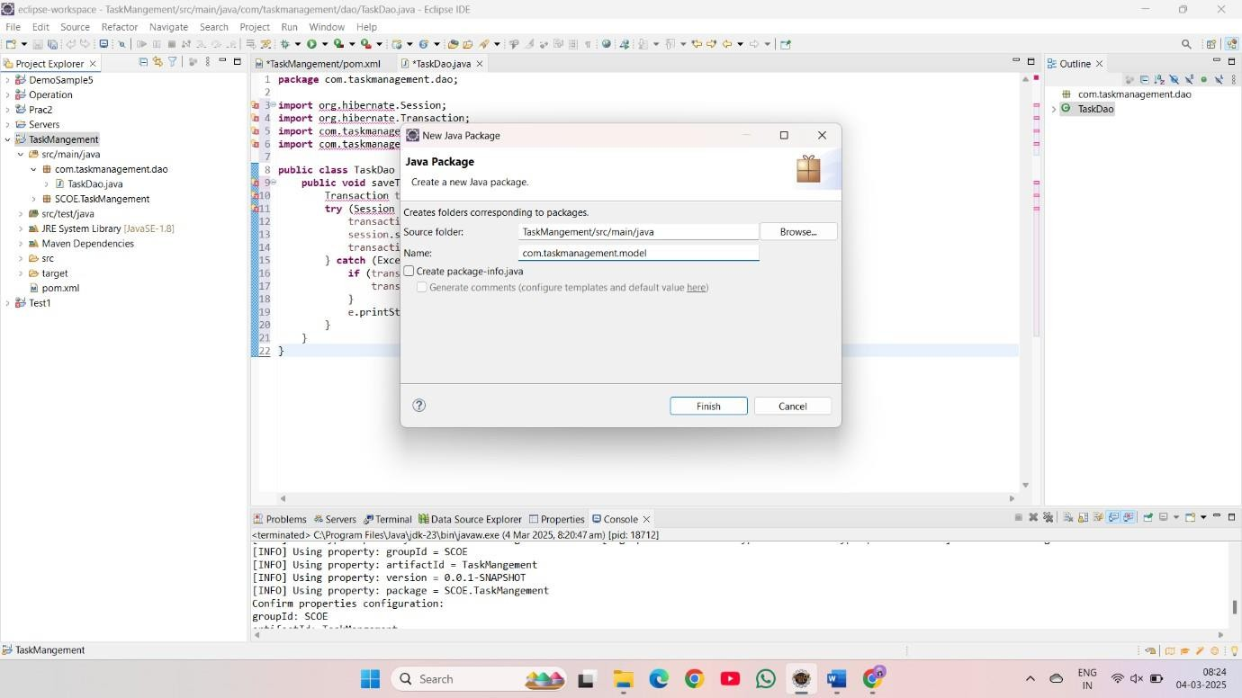

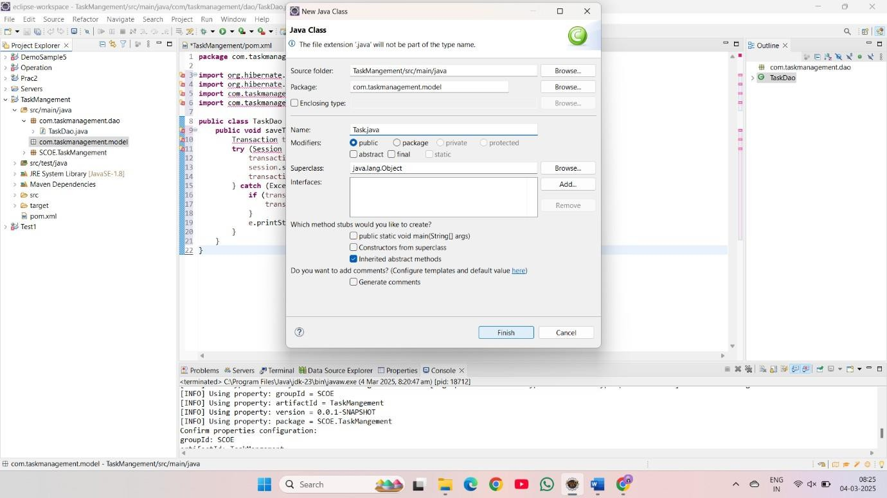

package com.taskmanagement.model;

import jakarta.persistence.*;

@Entity

@Table(name = "Task") public class Task {

@Id

@GeneratedValue(strategy = GenerationType.IDENTITY) private int taskId;

@Column(name = "Task Name") private String taskName;

@Column(name = "Task Description") private String taskDescription;

@Column(name = "Status") private String status;

public Task() {}

public Task(String taskName, String taskDescription, String status) { this.taskName = taskName;

this.taskDescription = taskDescription; this.status = status;

}

// Getters and Setters

}

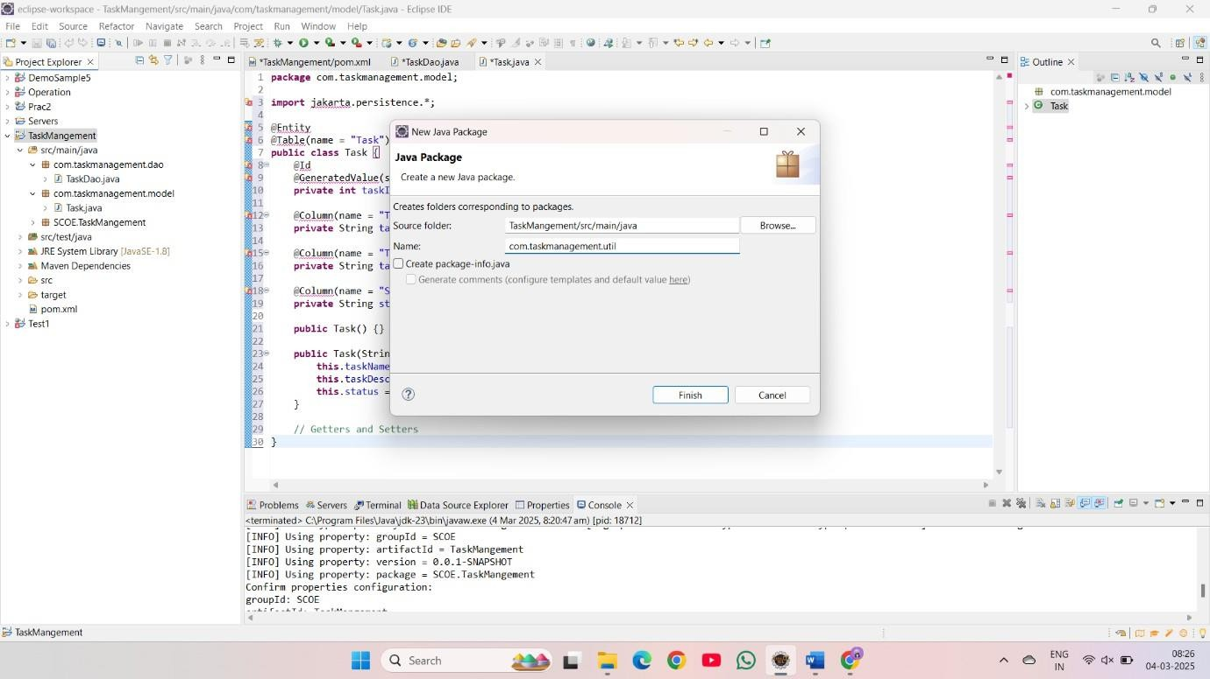

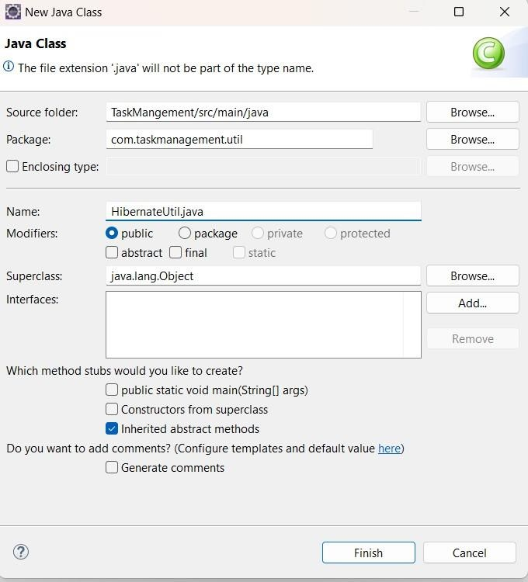

package com.taskmanagement.util;

import java.util.Properties;

import org.hibernate.SessionFactory;

import org.hibernate.boot.registry.StandardServiceRegistryBuilder; import org.hibernate.cfg.Configuration;

import org.hibernate.cfg.Environment; import org.hibernate.service.ServiceRegistry; import com.taskmanagement.model.Task;

public class HibernateUtil {

private static SessionFactory sessionFactory;

public static SessionFactory getSessionFactory() { if (sessionFactory == null) {

try {

Configuration configuration = new Configuration(); Properties settings = new Properties();

settings.put(Environment.DRIVER, "com.mysql.cj.jdbc.Driver"); settings.put(Environment.URL, "jdbc:mysql://localhost:3306/taskdb"); settings.put(Environment.USER, "root"); settings.put(Environment.PASS, "");

settings.put(Environment.DIALECT, "org.hibernate.dialect.MySQL5Dialect"); settings.put(Environment.SHOW_SQL, "true"); settings.put(Environment.HBM2DDL_AUTO, "update"); configuration.setProperties(settings); configuration.addAnnotatedClass(Task.class);

ServiceRegistry serviceRegistry = new StandardServiceRegistryBuilder()

.applySettings(configuration.getProperties()).build(); sessionFactory = configuration.buildSessionFactory(serviceRegistry);

} catch (Exception e) { e.printStackTrace();

}

}

return sessionFactory;

}

}

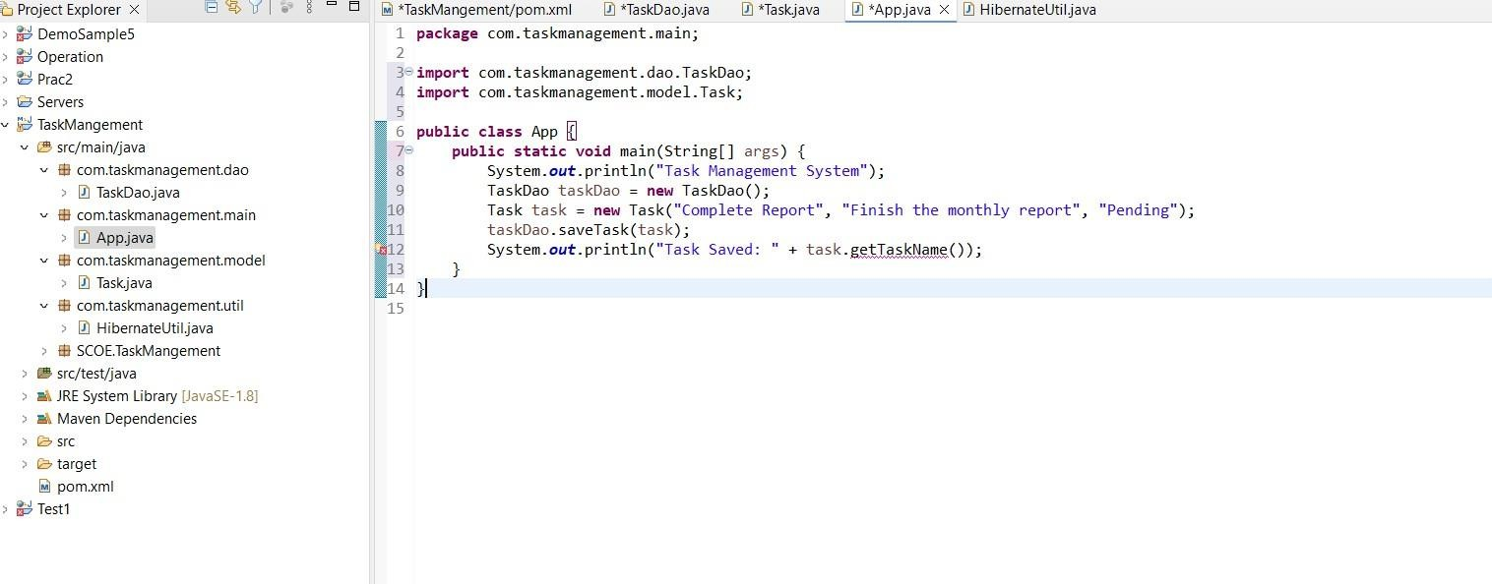

package com.taskmanagement.main;

import com.taskmanagement.dao.TaskDao; import com.taskmanagement.model.Task;

public class App {

public static void main(String[] args) { System.out.println("Task Management System"); TaskDao taskDao = new TaskDao();

Task task = new Task("Complete Report", "Finish the monthly report", "Pending"); taskDao.saveTask(task);

System.out.println("Task Saved: " + task.getTaskName());

}

}

Output:

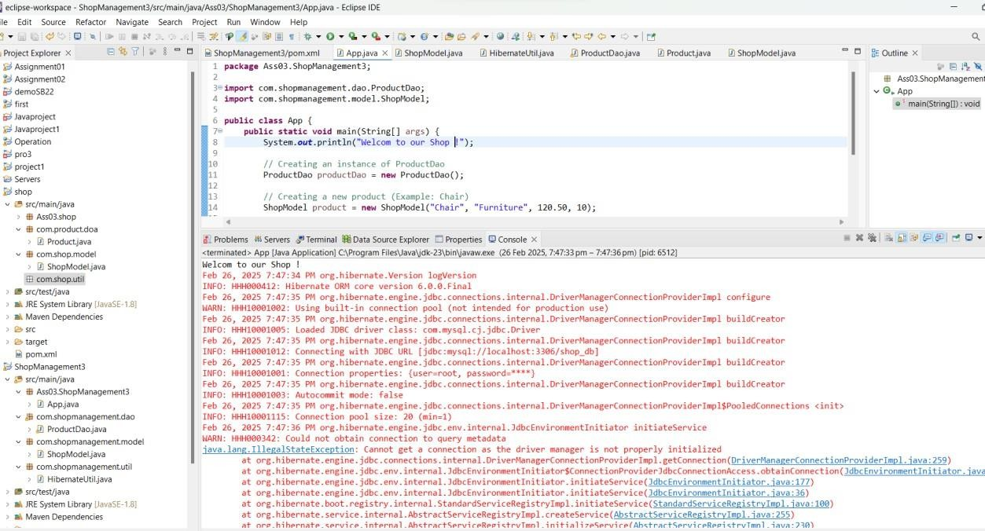

INFO: HHH000400: Using dialect: org.hibernate.dialect.MySQLDialect

WARN: HHH000206: MySQL5Dialect has been deprecated; use org.hibernate.dialect.MySQLDialect instead

INFO: HHH10001051: Connection obtained from JdbcConnectionAccess

Hibernate: create table Shop1 (productId integer not null auto_increment, 'Product Category' varchar(255), 'Product Name' varchar(255), primary key (productId)) engine=MyISAM

Hibernate: insert into Shop1 ('Product Category', 'Product Name') values (?, ?) 1